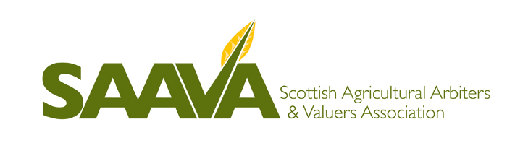
PRACTICAL EXAM TUTORIAL FOR CAAV EXAMINATIONS
FRIDAY 18TH MARCH 2016
MAINS OF THORNTON, LAURENCEKIRK, KINCARDINESHIRE, AB30 1EB
(By the kind permission of Ian Thornton-Kemsley and Andrew Moir)

- I wish to attend the above tutorial and enclose a cheque for £20 made payable to SAAVA.

Name ………………………………………………………………….
Firm ………………………………………………………………….
Address ………………………………………………………………….
…………………………………………………………………......................
………………………………………………Postcode………......................
Telephone …………………………………………………………………
Email …………………………………………………………………

Please return this form to our Administrative Secretary Christine Nisbet details below; with your cheque made payable to ‘SAAVA’ or alternatively BACS payments can be made to the following account no later than Friday 11th March 2016.
Account Name – SAAVA
Royal Bank of Scotland
Sort Code – 83 23-18
Account Number – 0011 0096

Administrative Secretary
Christine Nisbet,
SAAVA,
C/o Seed & Co,
Cothill,
Duns,
Berwickshire,
TD10 6YW.

